Requirement
Custom role user should be able to create an Update Set and capture changes in that Update Set without giving admin role.

Step 1: Create custom role
Go to:
User Administration > Roles
Create role:
x_custom.update_set_user
You can use your own role name.

Step 2: Give this role to user
Go to:
User Administration > Users
Open the user record.
Add role:
x_custom.update_set_user

Step 3: Give access to Update Set table
Table:
sys_update_set
Create ACLs for your custom role.
Required ACLs:
- sys_update_set read
- sys_update_set create
- sys_update_set write
Role:
x_custom.update_set_user
This allows user to see, create, and update update sets.

Step 4: Give access to Customer Updates table
Table:
sys_update_xml
Create ACL:
- sys_update_xml read
Role:
x_custom.update_set_user
Usually users do not manually create records here. ServiceNow captures changes automatically when user modifies configuration records.

Step 5: Give module access
Go to:
System Update Sets > Local Update Sets
Open the module record.
Add your custom role in Roles field:
x_custom.update_set_user
Also check module:
System Update Sets > Retrieved Update Sets
Only give this if required.

Step 6: Allow user to select current update set
User should be able to open:
System Update Sets > Local Update Sets
Then create new update set.
After creating, user should click:
Make Current
If “Make Current” is not visible, check UI Action access.

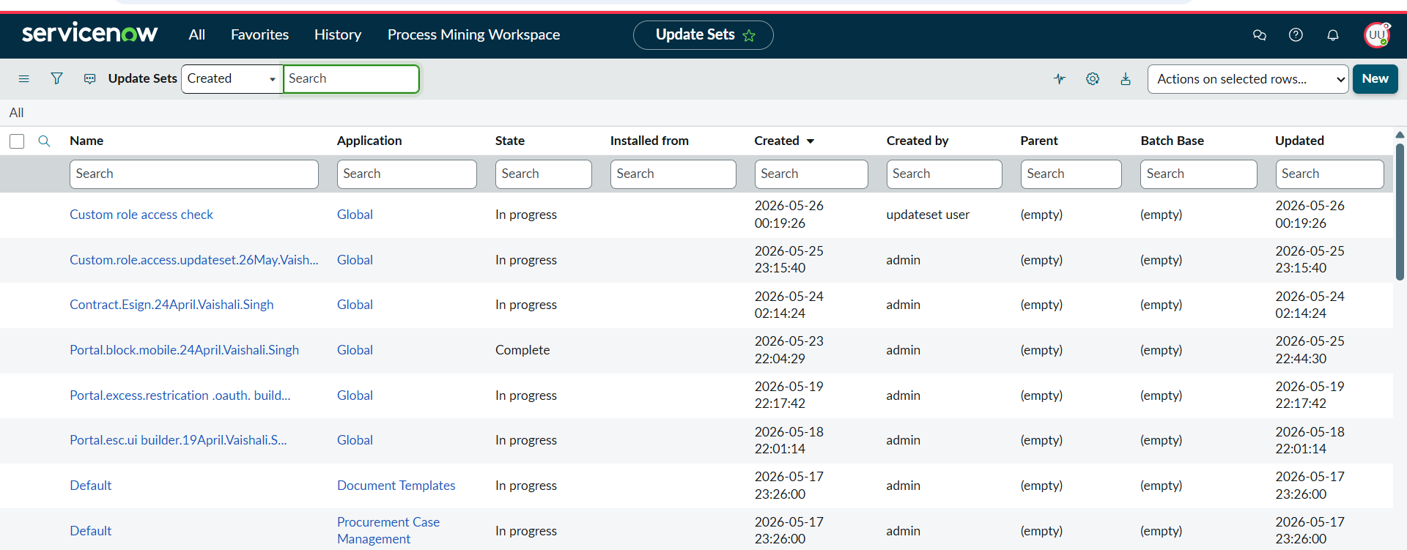

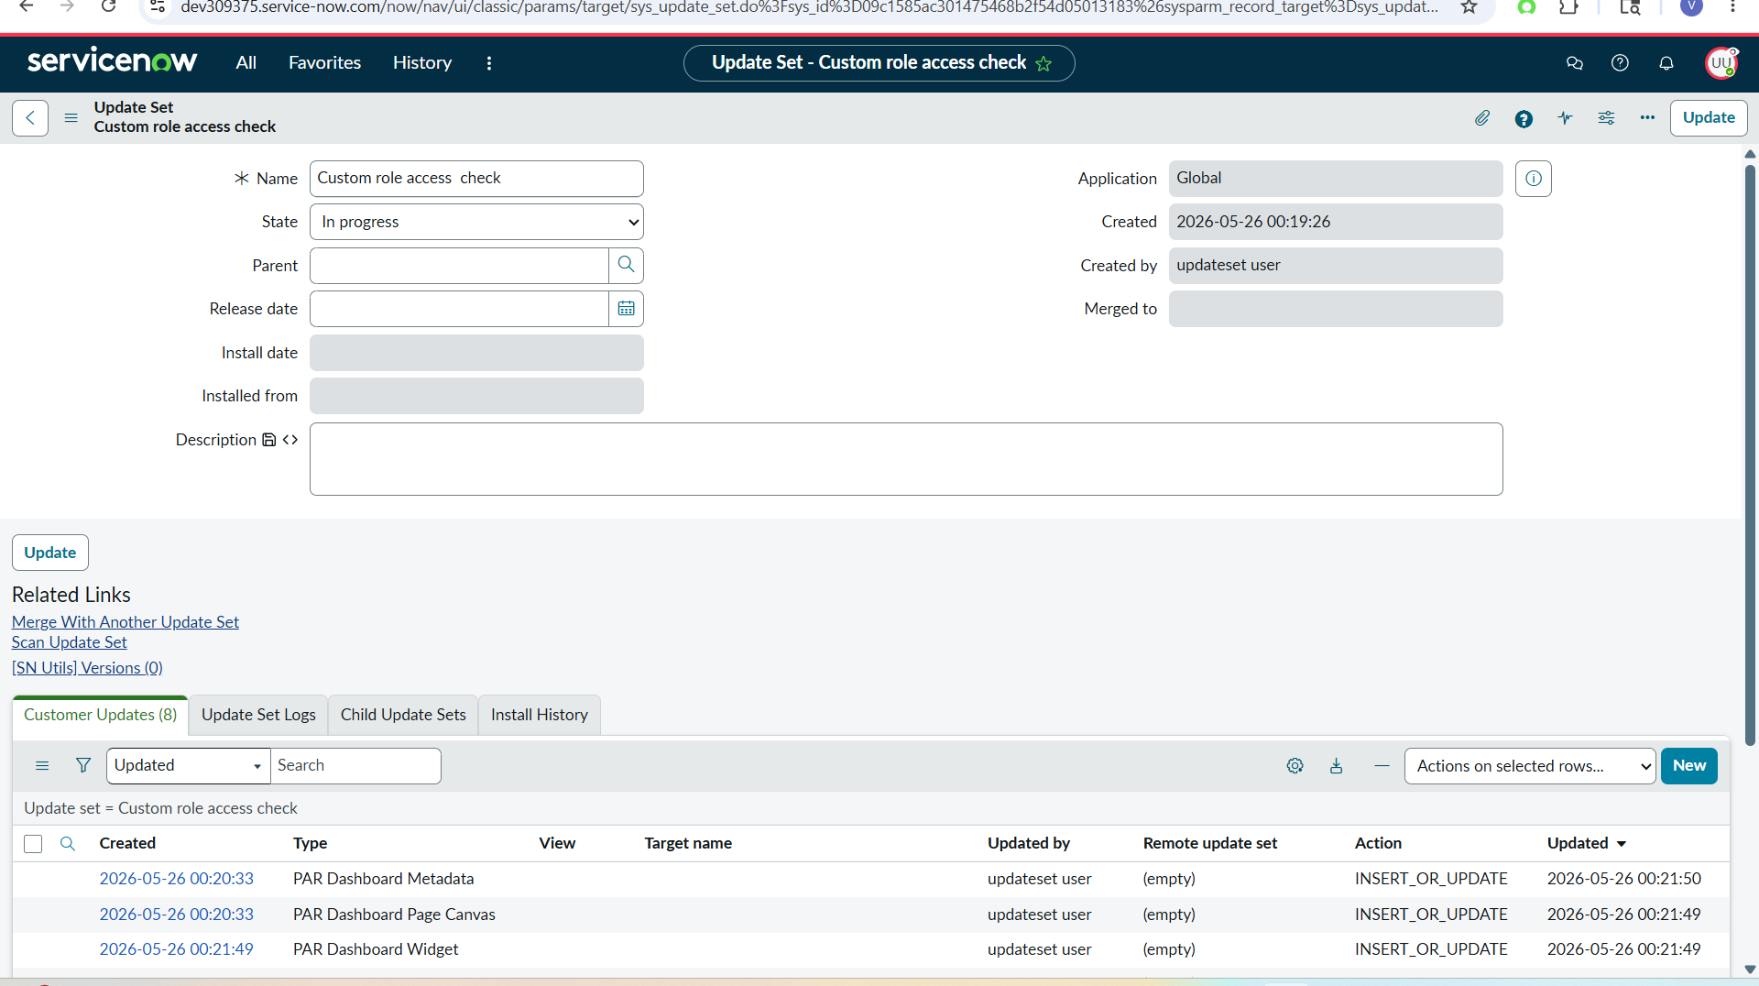

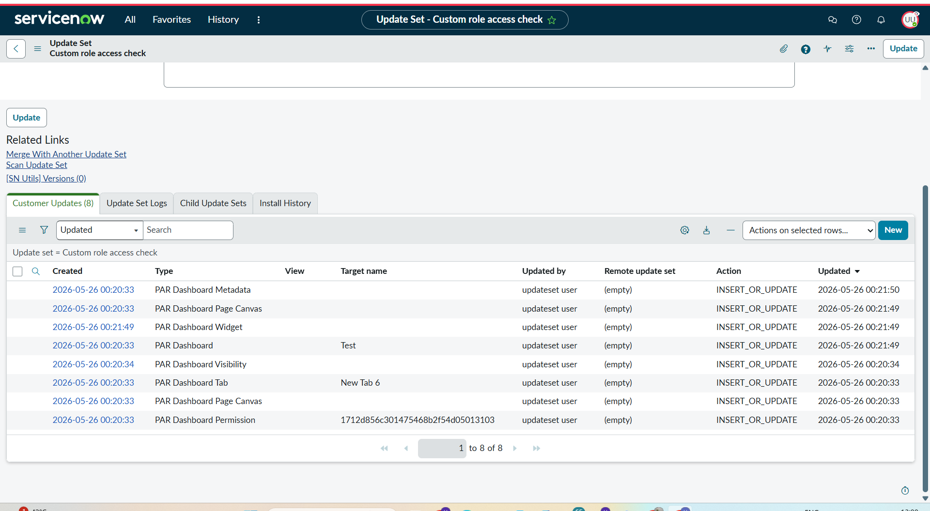

To capture/ retrieval update set

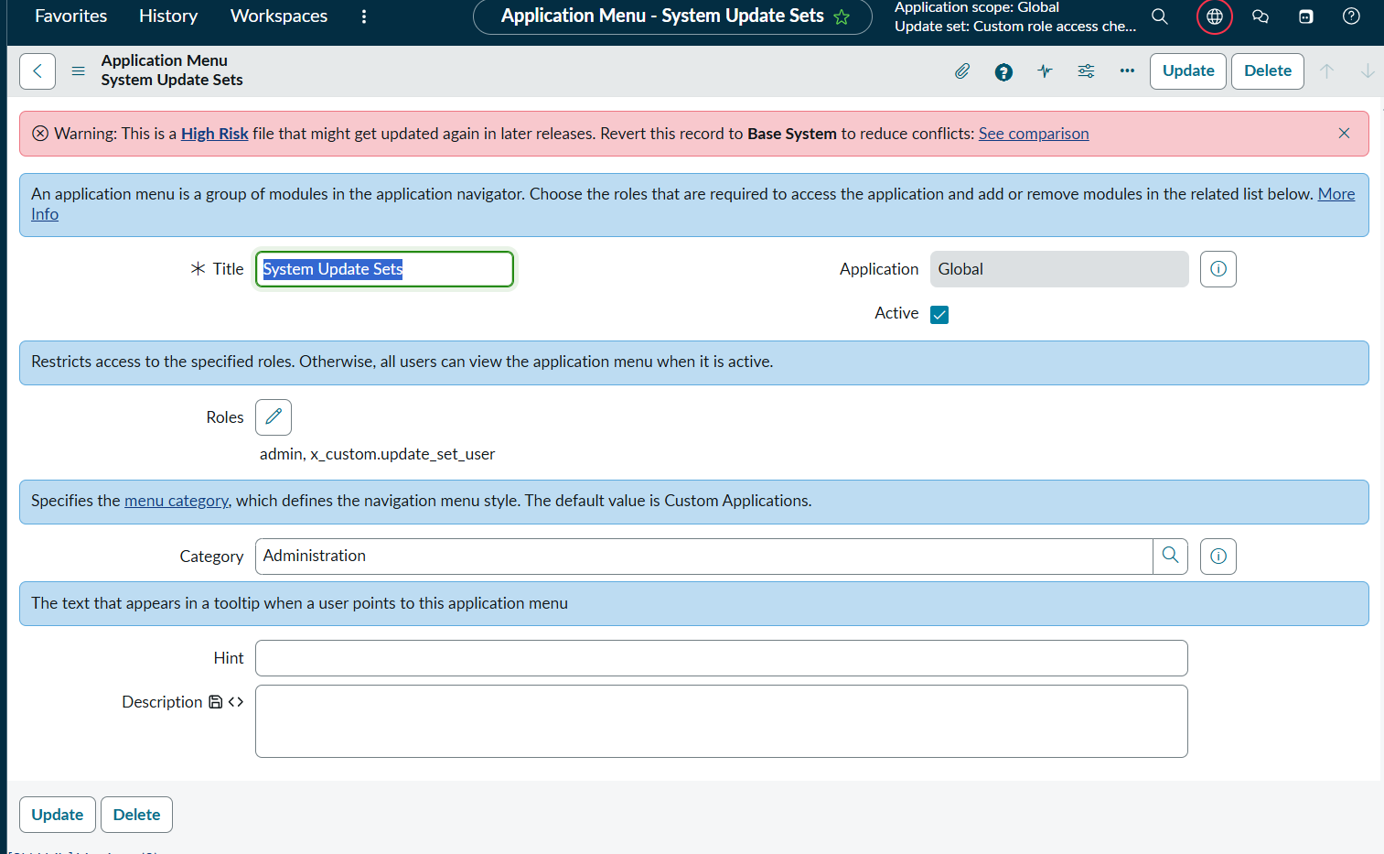

Still no option for export

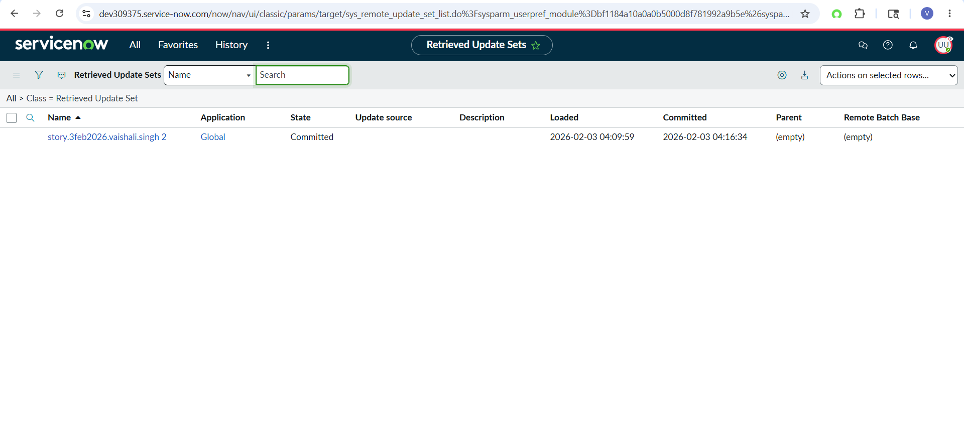

Because for export - oob export set role is required

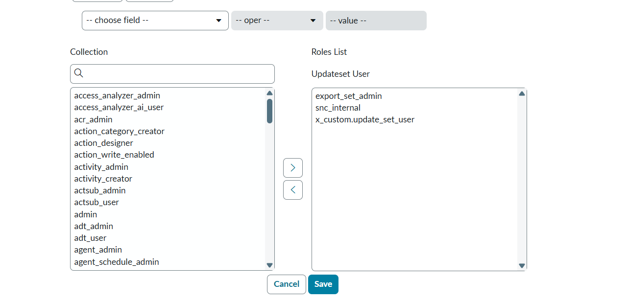

Add role here

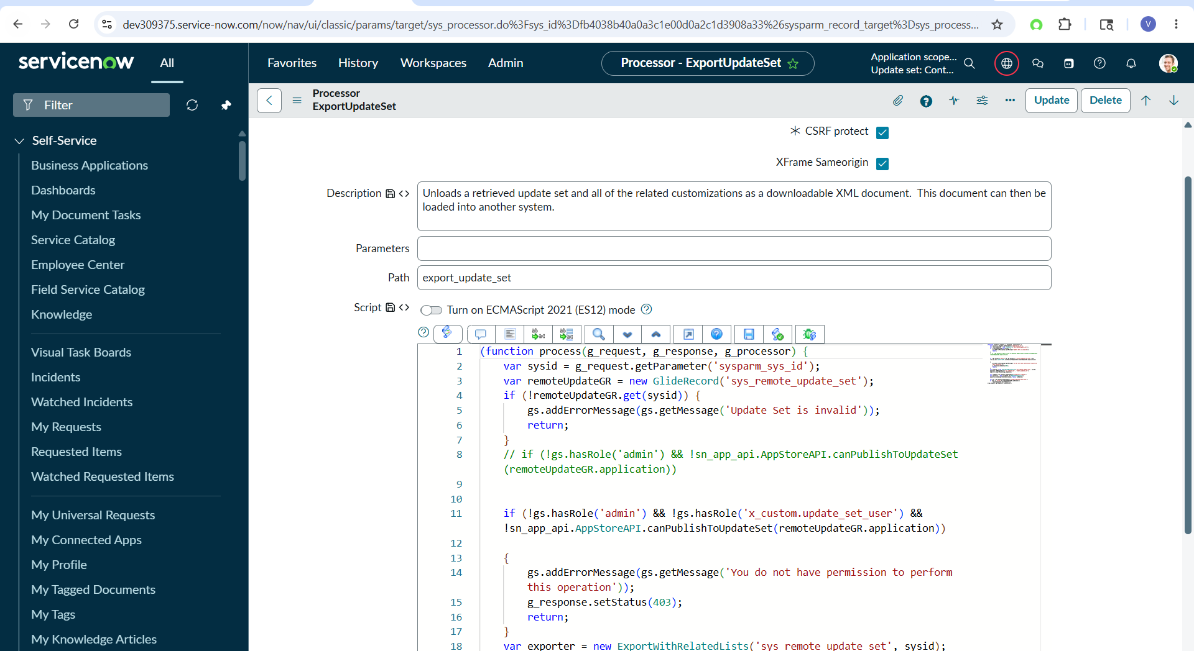

if (!gs.hasRole('admin') && !gs.hasRole('x_custom.update_set_user') && !sn_app_api.AppStoreAPI.canPublishToUpdateSet(remoteUpdateGR.application))

ADD role in ui action

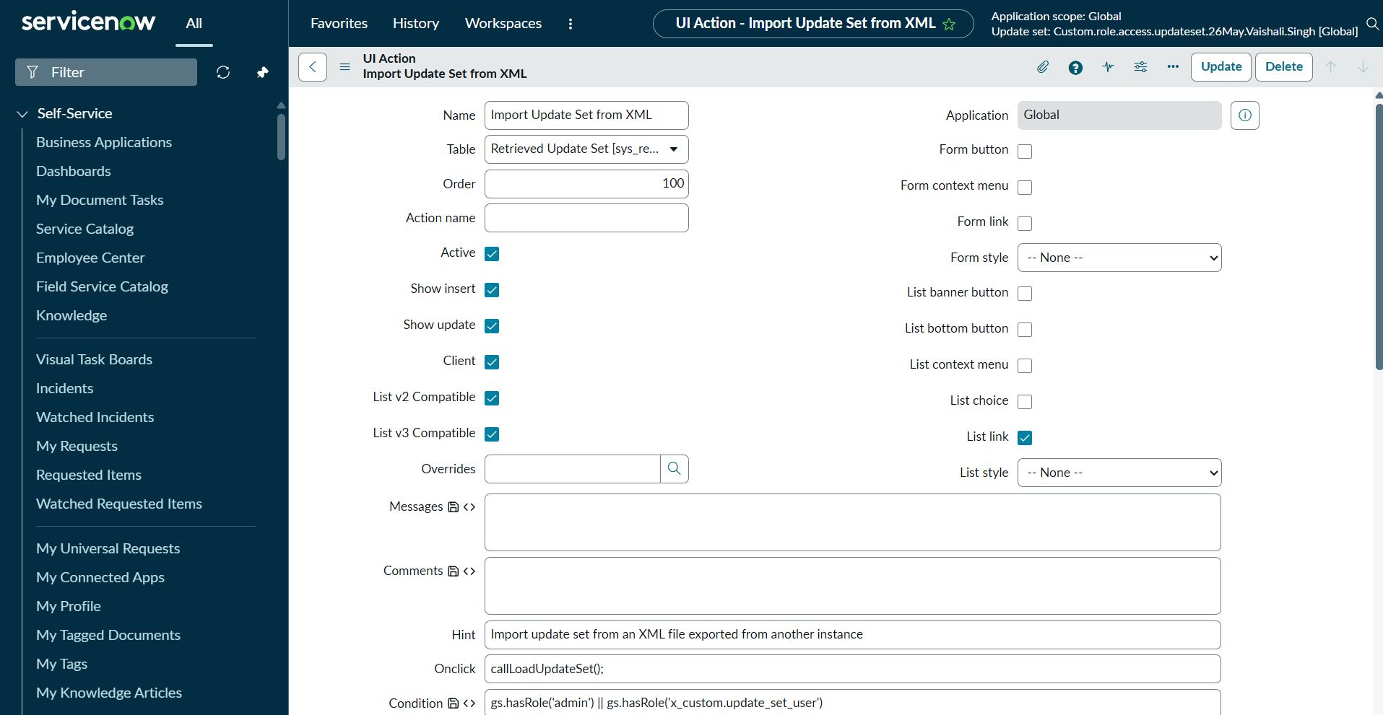

Now it work

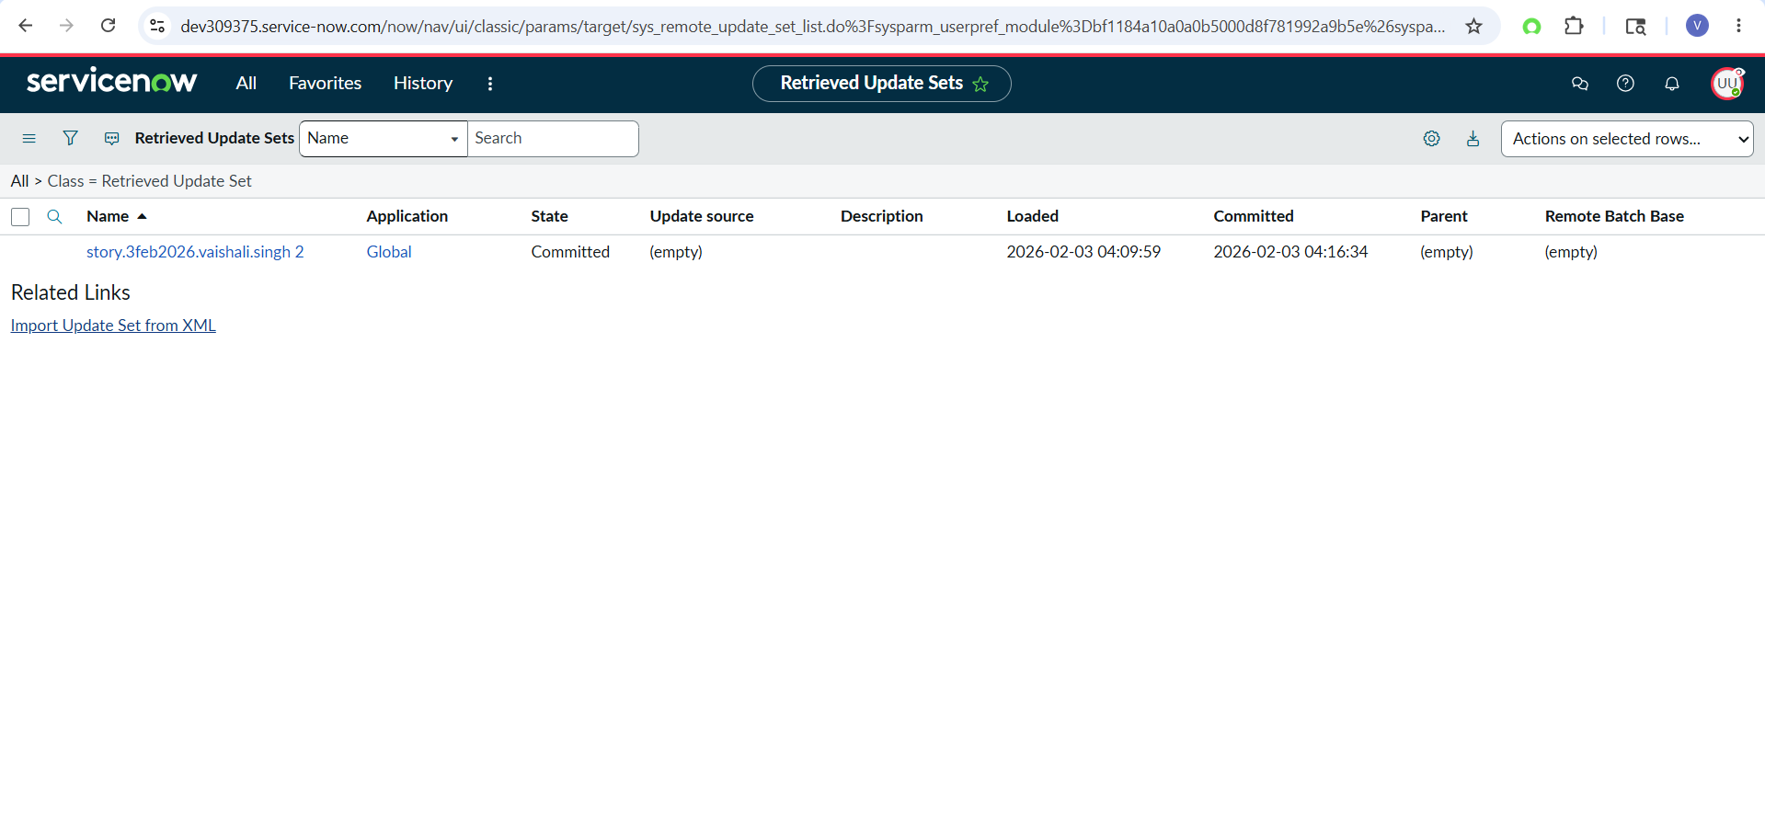

During upload

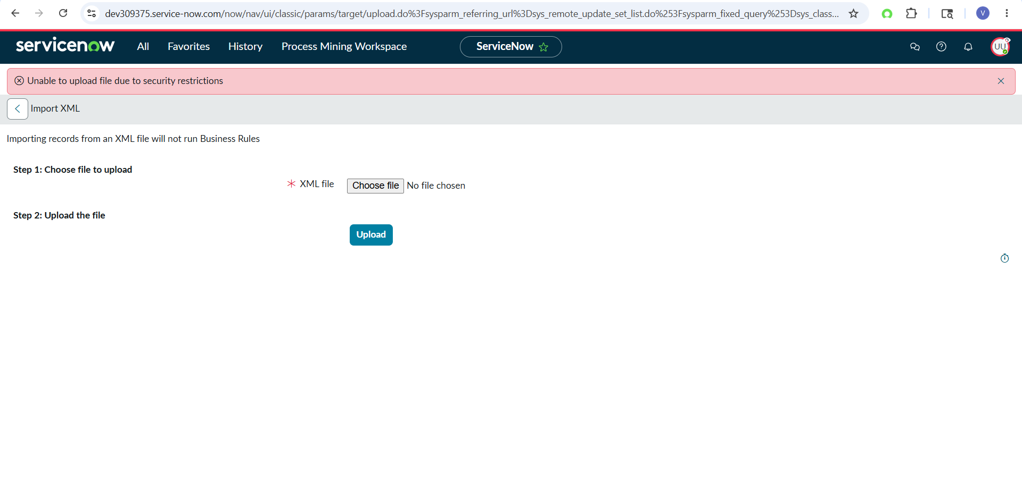

Add custom role to:
sys_attachment create ACL

Still it not work - servicenow internal critiria block

